**Full Stack Project Report**

**On**

**EnVoyageant - A Travelling Website**

Department of Computer Engineering & Applications

**Institute of Engineering & Technology**



**Submitted by**

**Nidhi Jain**

**Roll No: 181500423**

**Radhika Bansal**

**Roll No: 181500528**

**Sakshi Bhardwaj**

**Roll No: 181500608**

**Supervised By: -**

**Mr. Pankaj Kapoor**

**Department of Computer Engineering & Application**

**Department of Computer Engineering and Applications**

**GLA University, 17 km. Stone NH#2, Mathura-Delhi Road, Chaumuha, Mathura – 281406 U.P (India)**



**Declaration**

I/we hereby declare that the work which is being presented in the B.Tech. Project **“EnVoyageant-A Travelling Website”**, in partial fulfilment of the requirements for the award of the ***Bachelor of Technology*** in Computer Science and Engineering and submitted to the Department of Computer Engineering and Applications of GLA University, Mathura, is an authentic record of my/our own work carried under the supervision of **Mr. Pankaj Kapoor.**

The contents of this project report, in full or in parts, have not been submitted to any other Institute or University for the award of any degree.

Sign ______________________ Sign ______________________

Name of Candidate: Nidhi Jain Name of Candidate: Radhika Bansal

University Roll No.: 181500423 University Roll No.: 181500528

Sign ______________________

Name of Candidate: Sakshi Bhardwaj

University Roll No.: 181500608

Acknowledgement

In the present world of competition there is a race of existence in which those are having will to come forward succeed. Project is like a bridge between theoretical and practical working. With this willing we joined this particular project. It gives us great pleasure and we are glad to represent the report of our B.Tech Full Stack Project undertaken during the third year of our graduation era.

It has indeed been a great privilege for us to have Mr. Pankaj Kapoor Department of Computer Engineering & Application, Institute of Engineering & Technology, GLA University, Mathura, as our mentor in this Project. His awe-inspiring personality, superb guidance and constant encouragement are the motive force behind this project. We take this opportunity to express our utmost gratitude to him. We are also indebted to her for her timely and valuable advise.

We are highly grateful to Prof. Anand Singh Jalal, Head, Department of Computer Engineering & Application for providing necessary facilities and encouraging us during the course of work. We are thankful to all technical and non-technical staff of the Department of the Computer Science and Engineering for their constant assistance and their co-operation.

**ABSTRACT**

Online tours and travels is a web based project where a user can apply and search for a package. The system allows the user to check various tour packages and choose its package accordingly. The software system checks for user choice and then queries the database for various available packages to that destination. The system then loads all that data and puts those choices in front of the user. The user can now choose various packages as per his desire. When the user chooses the type of package option, the system allows the user to book the package of the destination for the desire date. Thus the software automates the working of a travel agency and allows users to check and book his holidays online through this website.

**CONTENTS**

Declaration ii

Certificate iii

Acknowledge iv

Abstract v

**CHAPTER 1 Introduction 1**

1.1 Project Introduction 1

1.2 Problem Statement 2

1.3 Main Objective 3

**CHAPTER 2 System Specifications 4**

2.1 Technical Feasibility 4

**CHAPTER 3 Techniques 5**

3.1 HTML 6

3.2 CSS 9

3.3 JavaScript & Jquery 11

**CHAPTER 4 Code Overview with screenshots 14**

**CHAPTER 5 Website Overview 18**

**CHAPTER 6 Conclusion 30**

**Project Introduction**

"Pack your bags. We are going on vacation!"

We are creating a real-time website to 'take a tour of India' effectively and effortlessly having great features involved. This site accommodates attractive interfaces that are easily accessible and understandable by the users. Altogether, this website will include all travel destinations to visit like a social travelling website that has all the places worth a visit or explores the most by the people. It provides the top-notch bookings for nearby best hotels available to stay to make it easy for tourists so that they won't face any problem at the time of their visit. This site will provide the leading facility of tourist guides which will help the visitors to know more about the place. This website will also work as a service provider like the need for cabs at the destination place. It also involves nearby visiting public spots and also mentions the popular foodstuffs and restaurants, shopping malls and many more places to wander around.

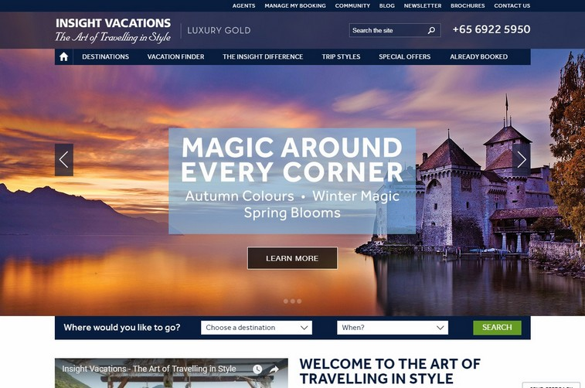

**Problem statement**

We are dealing with the situations of making things easier for the people who plan for a vacation or a tour. This website will help the people to plan their holiday for a magnificent place with the utmost facilities. In today's era, building the trust of people and finding all the services in one place is most difficult. People are compelled to look at different websites for different offerings and better facilities, but this site will engage them more effectively with its good facilities. Beyond serving a trustworthy source of inspiration for planning a trip, this site will also give would-be travellers all the information clearly and evidently that they required to arrange their travel plans.

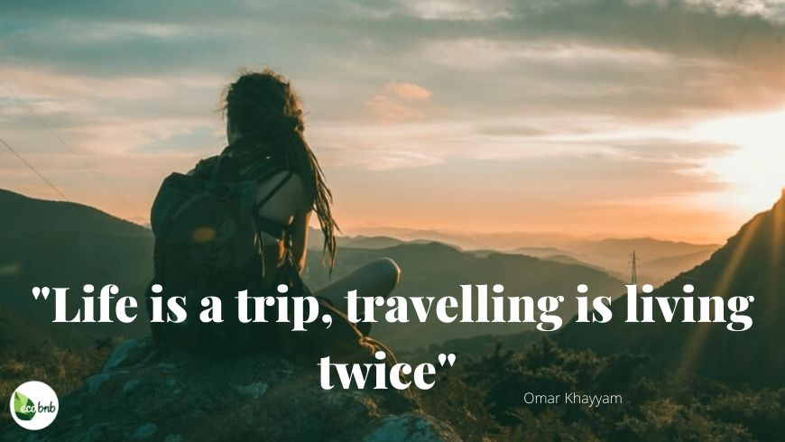

Objective of the project

"Designing a travel website is more than including pretty images of exotic destinations and hoping that your viewers complete their booking."

Gone are the days when travellers used to be satisfied with the services offered by offline travel agents and group tours. In today's era of millennials and digital natives, travellers are highly picky. They want something out of the ordinary. They are looking for highly curated travel experiences that perfectly suit their personalities. People travel preferences have changed significantly in recent years. Now, people prefer to travel to a historical and religious site, rich in culture and heritage. Solo travel has increased dramatically. The purpose of the website is the principal fact that Internet users are increasing today, so to facilitate offline customers online because customers cannot spend their precious time in markets trying to find out the best deals. This site will provide users with the right information at the right time and with the enormous facilities. This site will intent to connect with the audience elegantly. Hence it is essential to have a strong and reliable front-end which can withhold the users on the site.

Our design objectives are:

* A Responsive, Mobile-friendly Design
* Clean, Easy-to-Use and User-friendly Search forms
* Being Comprehensive and provide Complete Information
* User-engaging and Attractive Interfaces

**Working Methodology**

The resources used for designing and developing this project are the front-end techniques which have to be implemented on a text editor. Firstly, we prepare a design format for the website of how our website will look like and what functionality will cover which area of the website. Then, we will work on how all these modules get connected and provide a better interface for interactivity and looks astonishing at the very first sight of the user.

The front-end techniques used in the project are:

* HTML
* CSS
* JavaScript
* jQuery

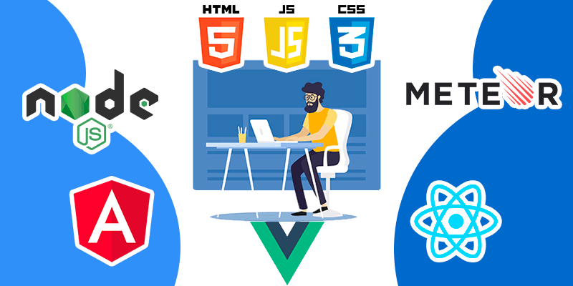

**HTML**

HTML stands for Hyper Text Markup Language. Hypertext Markup Language is the standard markup language for documents designed to be displayed in a web browser. It can be assisted by technologies such as Cascading Style Sheets and scripting languages such as JavaScript.HTML describes the structure of a Web page.

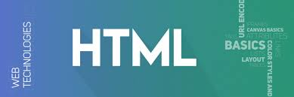

"Hypertext" refers to the hyperlinks that an HTML page may contain. "Markup language" refers to the way tags are used to define the page layout and elements within the page. Below is an example of HTML used to define a basic webpage with a title and a single paragraph of **text**.

HTML is an acronym which stands for **Hyper Text Markup Language** which is used for creating web pages and web applications. Let's see what is meant by Hypertext Markup Language, and Web page.

**Hyper Text:**  Hyper Text simply means "Text within Text." A text has a link within it, is a hypertext. Whenever you click on a link which brings you to a new webpage, you have clicked on a hypertext.HyperText is a way to link two or more web pages (HTML documents) with each other.

**Markup language:** A markup language is a computer language that is used to apply layout and formatting conventions to a text document. Markup language makes text more interactive and dynamic. It can turn text into images, tables, links, etc.

**Web Page:** A web page is a document which is commonly written in HTML and translated by a web browser. A web page can be identified by entering an URL. A Web page can be of the static or dynamic type.

**With the help of HTML only, we can create static web pages**.

Hence, HTML is a markup language which is used for creating attractive web pages with the help of styling, and which looks in a nice format on a web browser. An HTML document is made of many HTML tags and each HTML tag contains different content.

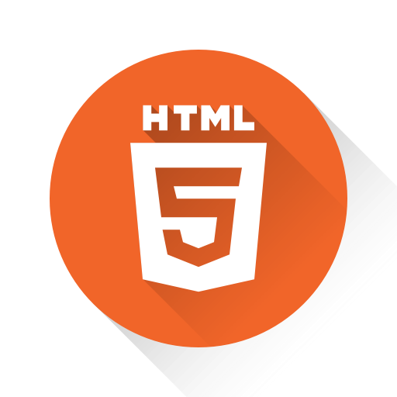

***Features of html***

* It is a very **easy and simple language**. It can be easily understood and modified.
* It is very easy to make an **effective presentation** with HTML because it has a lot of formatting tags.
* It is a **markup language**, so it provides a flexible way to design web pages along with the text.
* It facilitates programmers to add a **link** on the web pages (by html anchor tag), so it enhances the interest of browsing of the user.
* It is **platform-independent** because it can be displayed on any platform like Windows, Linux, and Macintosh, etc.
* It facilitates the programmer to add **Graphics, Videos, and Sound** to the web pages which makes it more attractive and interactive.
* HTML is a case-insensitive language, which means we can use tags either in lower-case or upper-case

**CSS**

**CSS** stands for **C**ascading **S**tyle **S**heets. CSS describes how HTML elements are to be displayed on screen, paper, or in other media. CSS saves a lot of work. It can control the layout of multiple web pages all at once. External stylesheets are stored in CSS files.

CSS is used to define styles for your web pages, including the design, layout and variations in display for different devices and screen sizes.

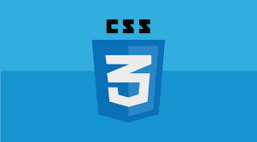

**CSS** is the language for describing the presentation of Web pages, including colors, layout, and fonts. It allows one to adapt the presentation to different types of devices, such as large screens, small screens, or printers. **CSS** is independent of HTML and can be **used** with any XML-based markup language.

**C**ascading **S**tyle **S**heets, fondly referred to as CSS, is a simple design language intended to simplify the process of making web pages presentable.

CSS handles the look and feel part of a web page. Using CSS, you can control the color of the text, the style of fonts, the spacing between paragraphs, how columns are sized and laid out, what background images or colors are used, layout designs,variations in display for different devices and screen sizes as well as a variety of other effects.

CSS is easy to learn and understand but it provides powerful control over the presentation of an HTML document. Most commonly, CSS is combined with the markup languages.

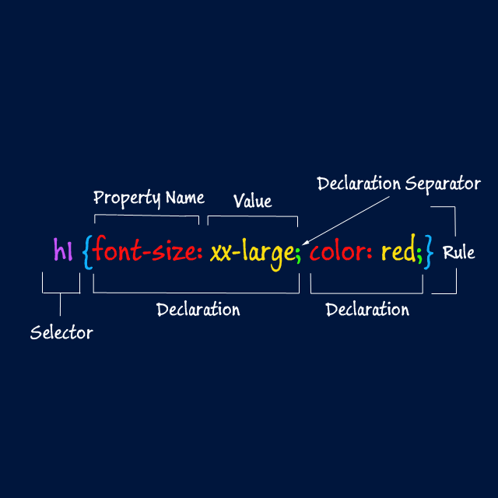

**Some of the advantages of using CSS are:**

* Easier to maintain and update.
* Greater **consistency** in design.
* More formatting options.
* **Lightweight** code.
* Faster download times.
* **Search engine optimization** benefits.
* Ease of presenting different styles to different viewers.
* Greater **accessibility**.

JavaScript

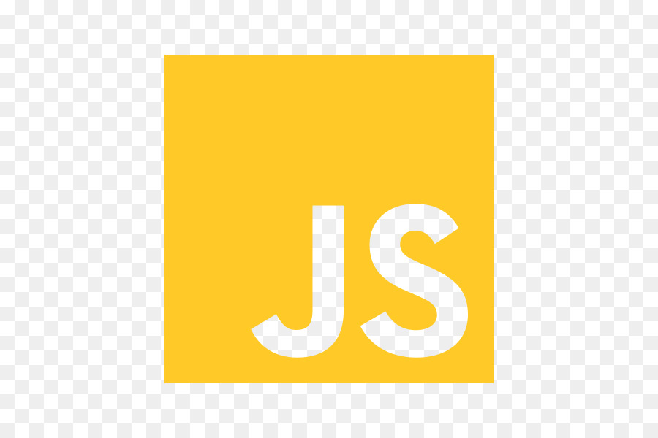JavaScript, often abbreviated as JS, is a programming language that conforms to the ECMAScript specification. JavaScript is high-level, often just-in-time compiled, and multi-paradigm. It has curly-bracket syntax, dynamic typing, prototype-based object-orientation, and first-class functions.

JavaScript is a text-based programming language used both on the client-side and **server**-side that allows you to make web pages interactive. Where HTML and **CSS** are languages that give structure and style to web pages, JavaScript gives web pages interactive elements that engage a user.

**Javascript** (JS) is a scripting languages, primarily used on the Web. It is used to enhance HTML pages and is commonly found embedded in HTML code. **JavaScript** is an interpreted language. Thus, it doesn't need to be compiled. **JavaScript** renders web pages in an interactive and dynamic fashion. **JavaScript** is a scripting or programming language that allows you to implement complex features on web pages — every time a web page **does** more than just sit there and display static information for you to look at such as displaying timely content updates, interactive maps, animated 2D/3D graphics etc.

The visual aspects of the website that can be seen and experienced by users are frontend. On the other hand, everything that happens on the background can be attributed to the backend. Languages used for front end are HTML, CSS, Javascript while those used for backend include **Java**, Ruby, Python.

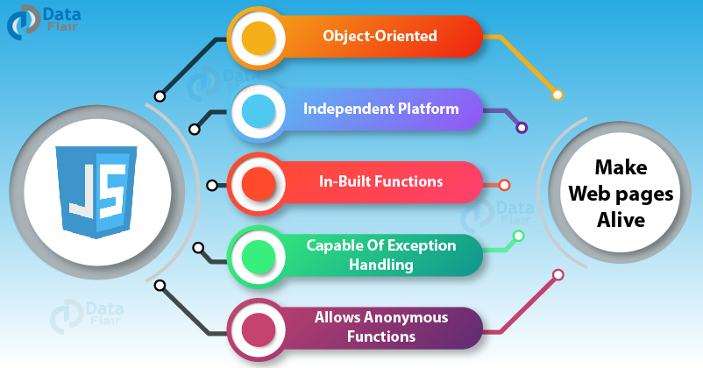

Things that we build using JavaScript:

* Websites: Okay, so you **can** file this one under 'pretty obvious'. ...
* Web Applications: As browsers and personal computers have continued to improve, so, too, has the abilities to create robust web applications. ...
* Presentations
* Server applications
* Web Servers
* Games
* Art

**jQuery**

jQuery is a JavaScript library designed to simplify HTML DOM tree traversal and manipulation, as well as event handling, CSS animation, and Ajax. It is free, open-source software using the permissive MIT License. As of May 2019, jQuery is used by 73% of the 10 million most popular websites.

**jQuery** is a lightweight, "write less, do more", JavaScript library. The purpose of  jQuery is to make it much easier to **use** JavaScript on your website. jQuery takes a lot of common tasks that require many lines of JavaScript code to accomplish, and wraps them into methods that you can call with a single line of code.

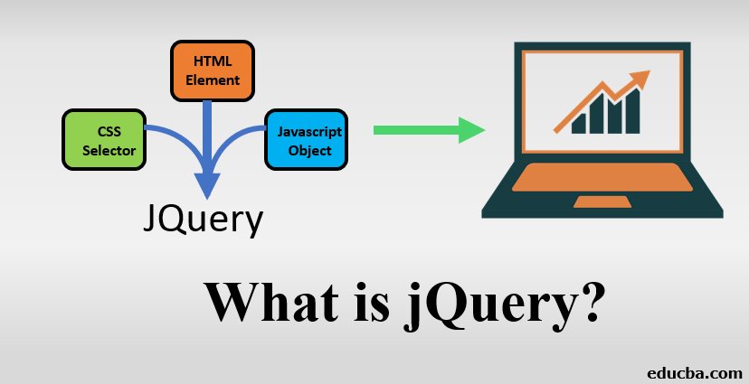

The main **difference** among the three is that **JavaScript** is client-side, i.e., **in the** browser scripting language, whereas **jQuery** is a library (or framework) built with **JavaScript**. At the same time, **jQuery** is a **JavaScript** framework that makes life easier for people who want to program for the browser.

As code of bootstrap and **jquery** majorly executed at client **end** so also responsible for style and look and feel of the UI. Mostly every application is being developed on two platforms i.e **backend** and **frontend** in which **backend** is developed by high level language such as JAVA,DOT NET etc.

**Overview of code**

**Code of HTML Files:**

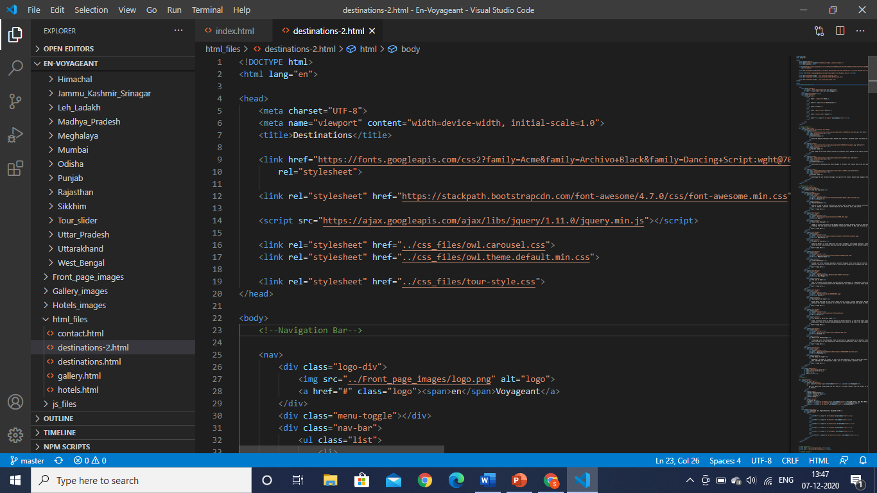

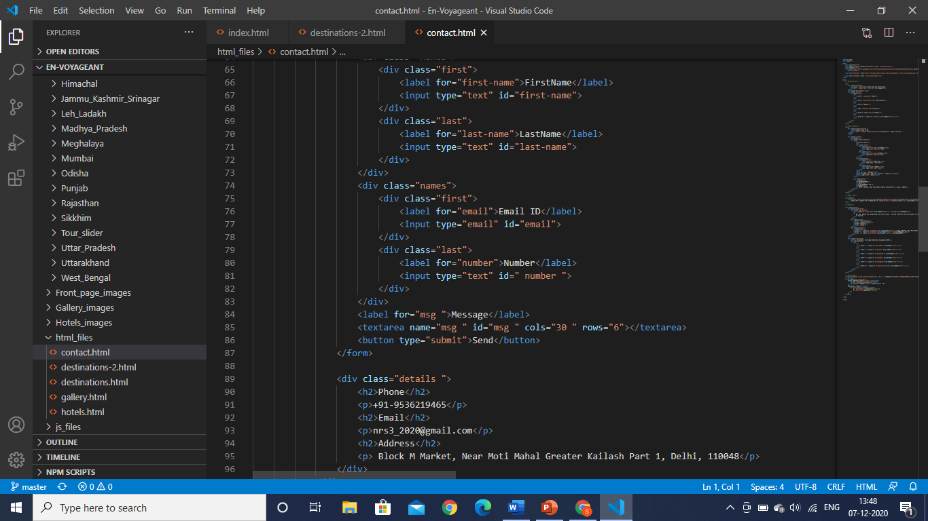

**Code of CSS files:**

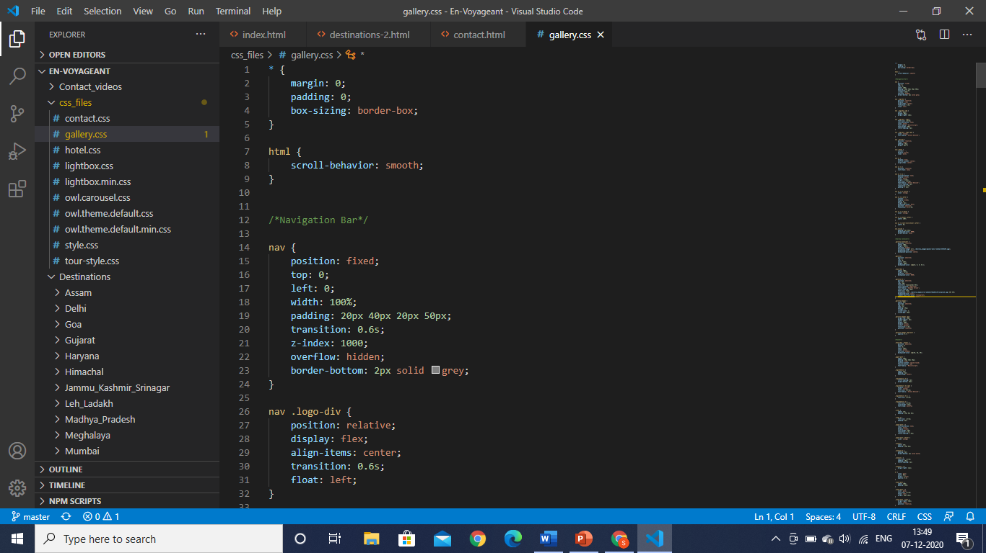

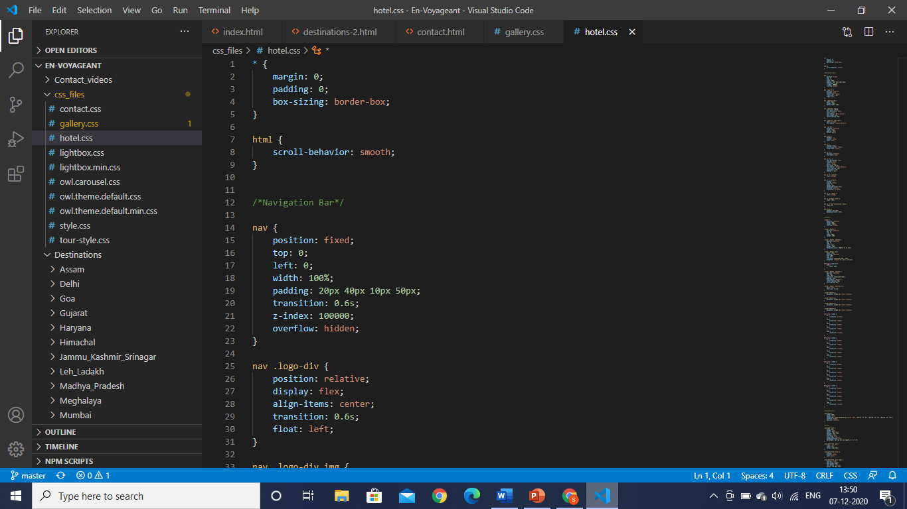

**Code of JS Files:**

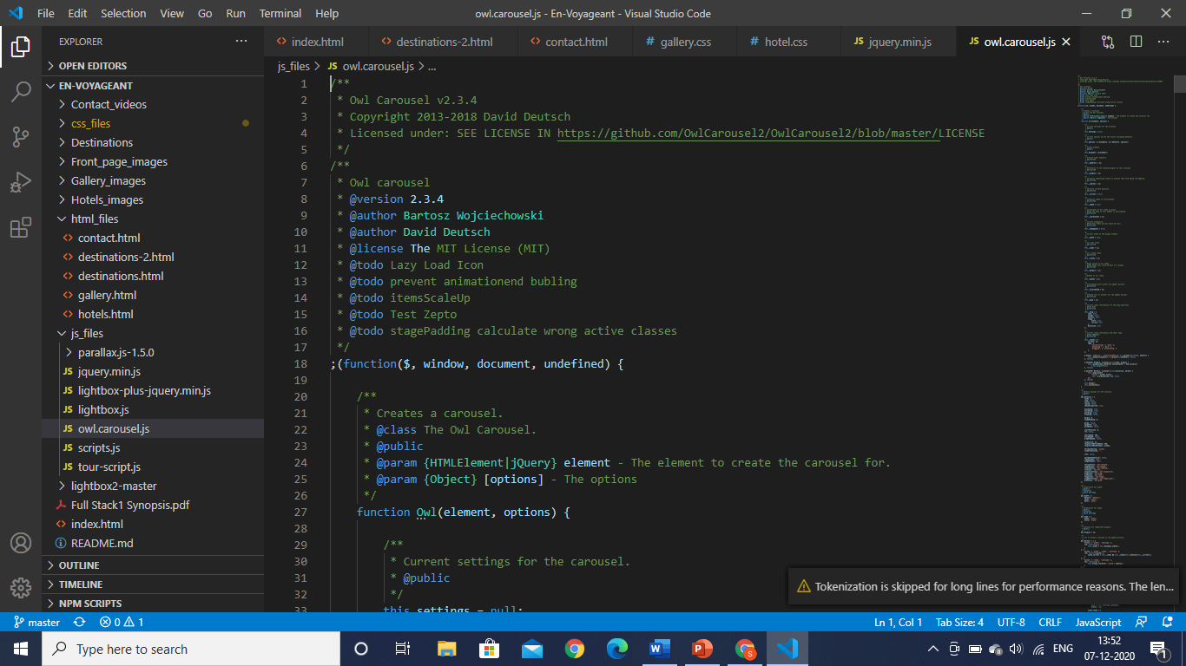

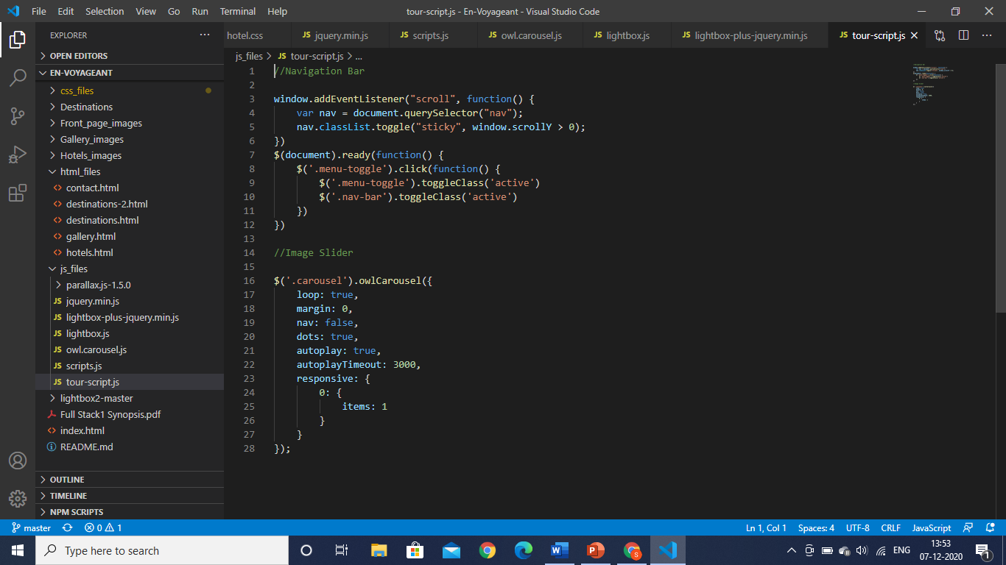

**jQuery code:**

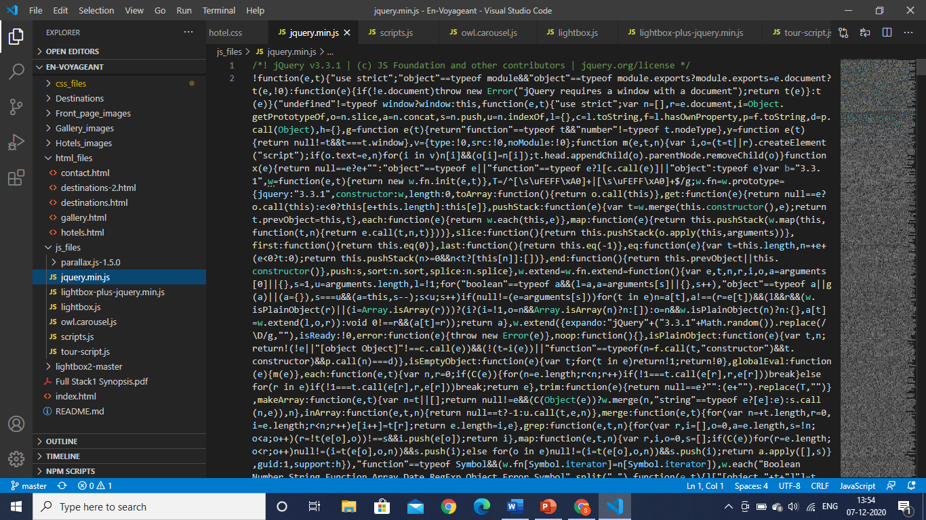

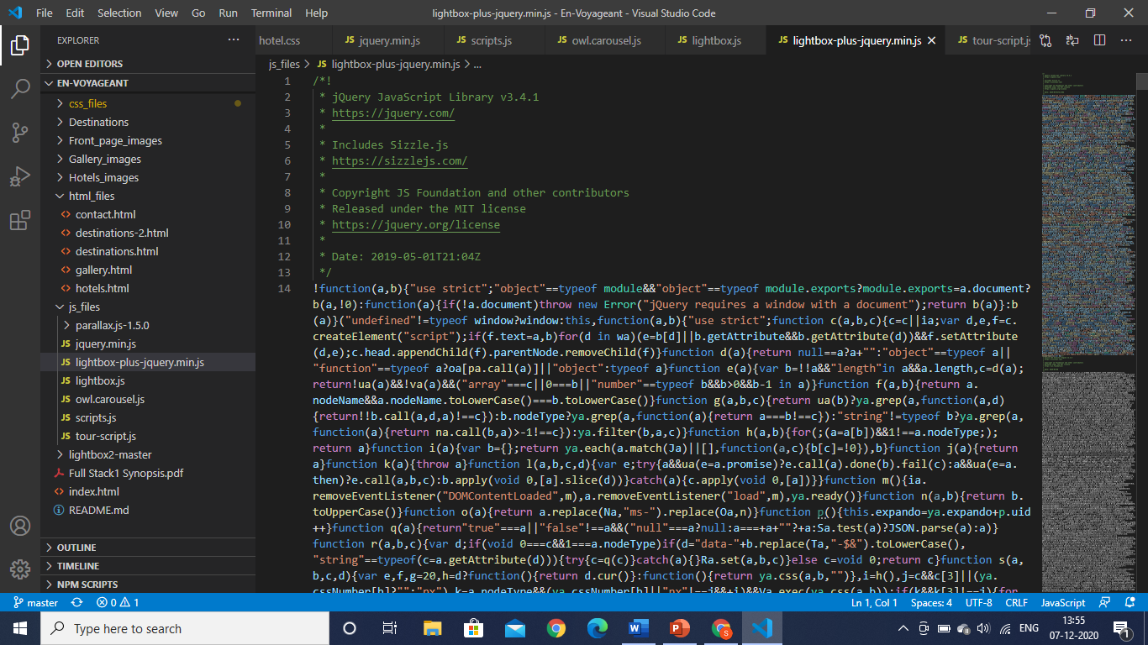

**Overview of our website working**

Our website is multi-page responsive site having five linked pages namely home, destination, hotel, gallery and contact page. It contains all the relevant information needed to the person like hotel booking, destination information and views of various person regarding destinations.

1. Home Page :

This page includes everything which describes our website front page like in starting we give a slider which tells the captions and especiallity of the website with proper responsiveness included for each device layout. The navigation bar is also properly responsive and also have a scrolling effect which changes color on scroll.

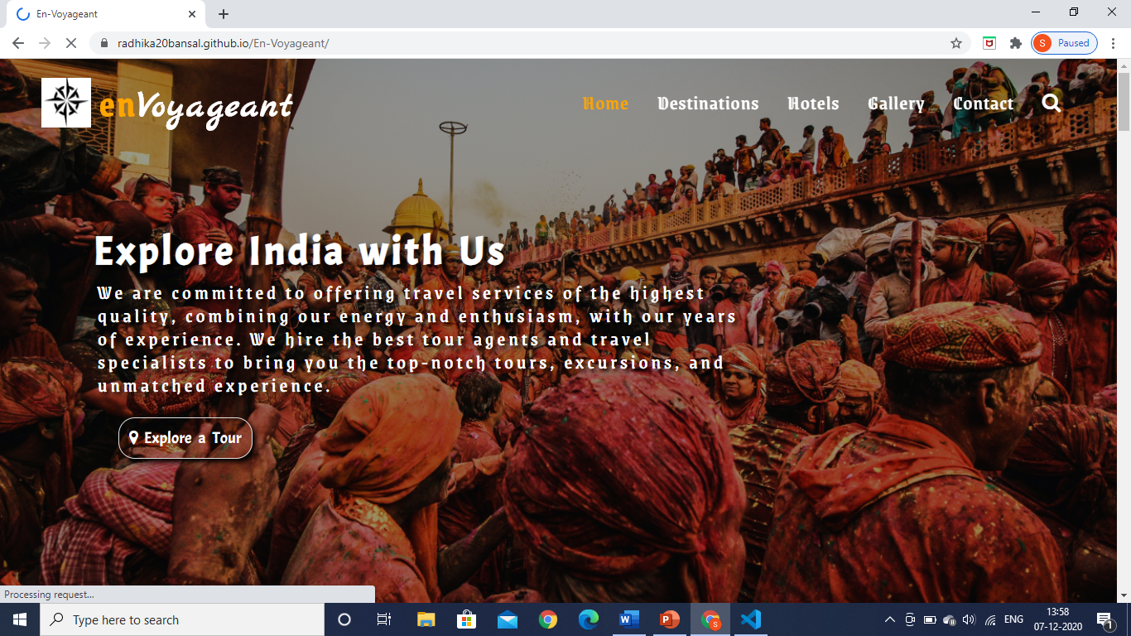

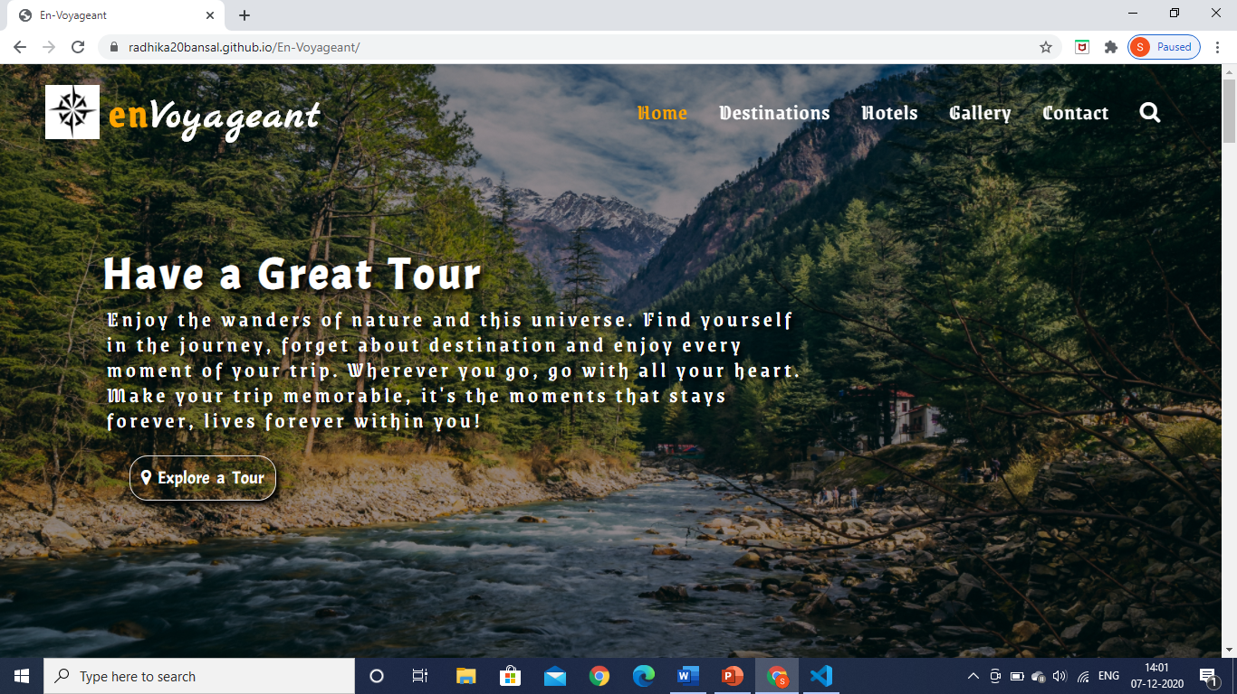

Here we add the cards for destinations/ places with an arrow slider which slides a card at a time. The cards have the information about the places with a smooth hover transition effect and blur effect. There is a button to view all the destinations included in the site. These cards are also responsive, like decreasing the screen size cards size reduce and eventually it changes to a single card on the screen.

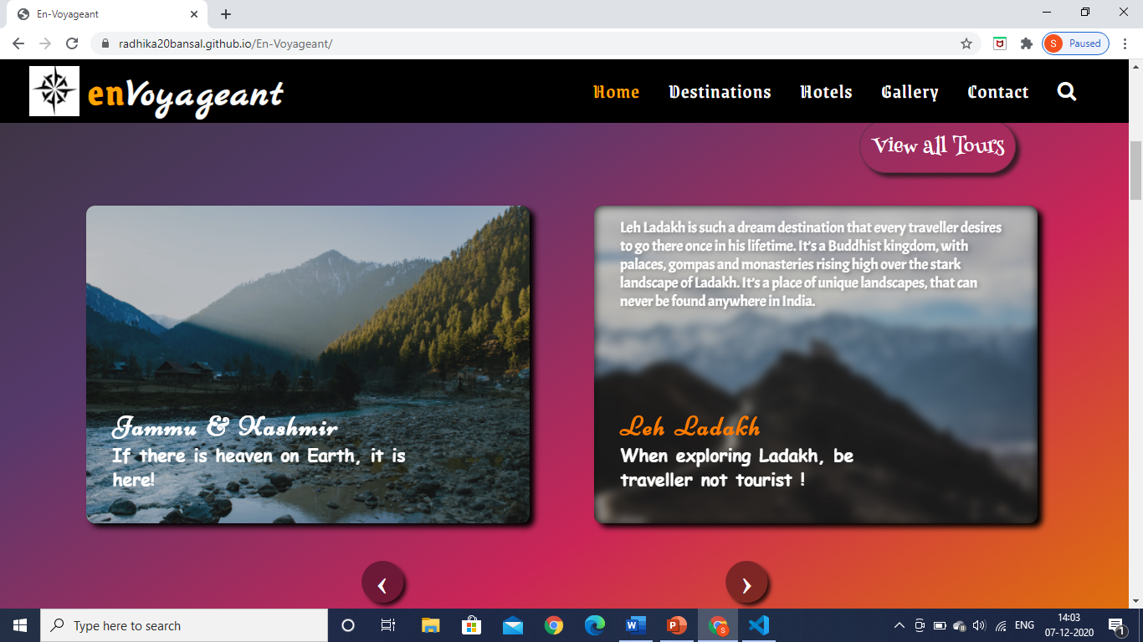

In this section, we wrote about the services we offered through this website which will be improved using backend technologies. We made cards for this also and a wonderful animation behind the cards which seems like a video but changing of several images to provide a soothing effect for the site. It is completely responsive having one card stacked over each other in view of mobile devices.

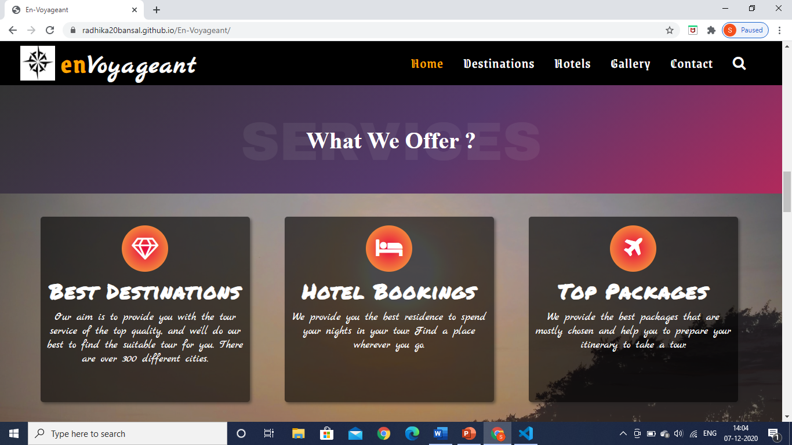

This is the testimonial section, we add some reviews of clients for our website which actually means when in market but we add it to make our website look great. We add carousel in this which chane the cards automatically and also stops on hover to read the reviews properly. It is also responsive for every device.

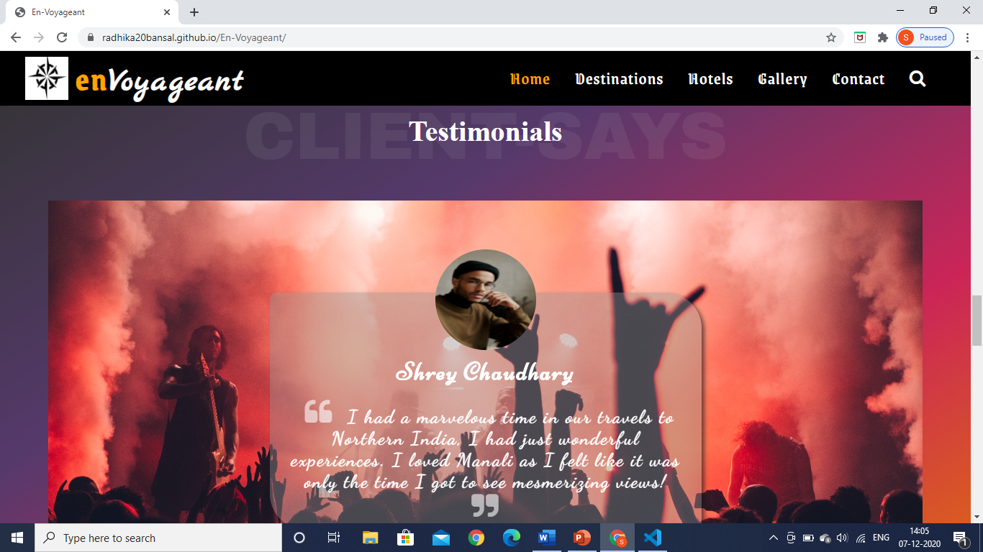

This is our project team members and in this section we talk about ourselves and our site.

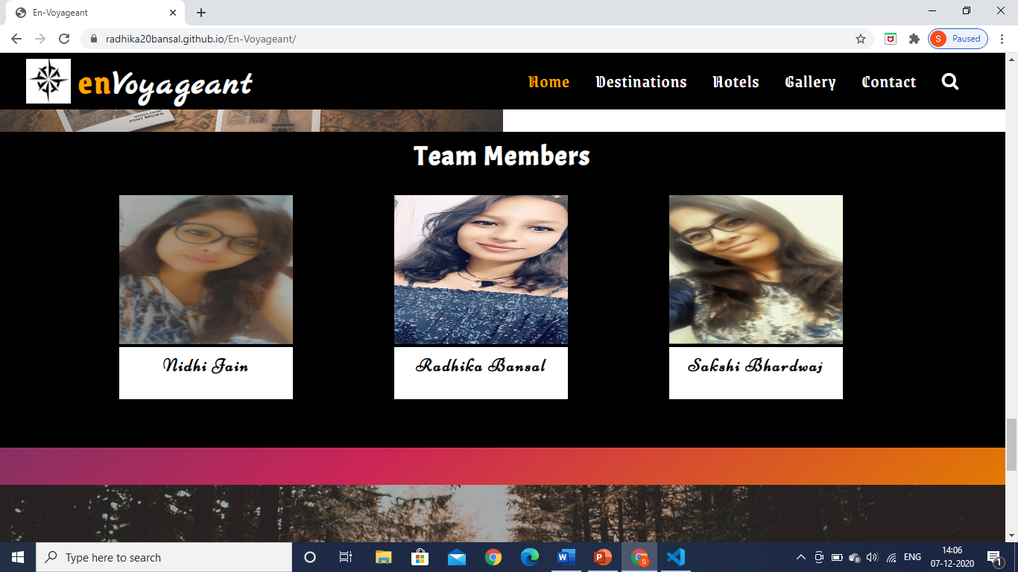

2. Destination Page:

This page includes all the destinations of India you can travel and enjoy your trip. Starting with a full screen carousel telling about each part of India like northern, eastern, southern and western India with similar images matching the culture of that part.

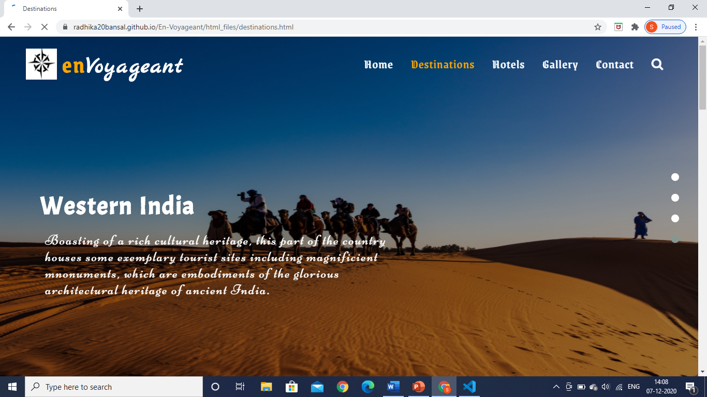

These are the card layouts of the tour places. On hovering the cards there appears a read more link and a beautiful transition effect. It also has link to next destination pages which contains our next or further places .

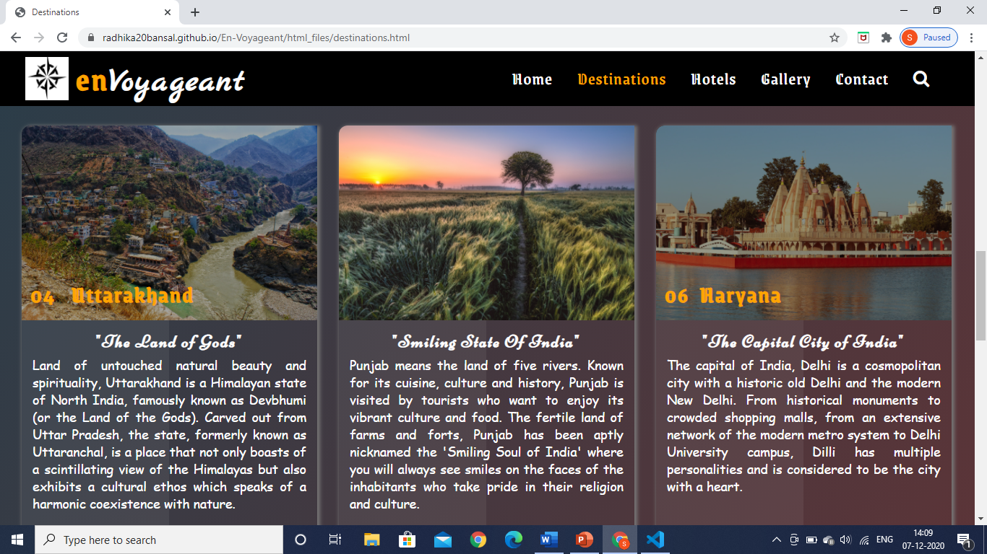

3. Hotel Page :

This page starts with a zoom out slideshow.

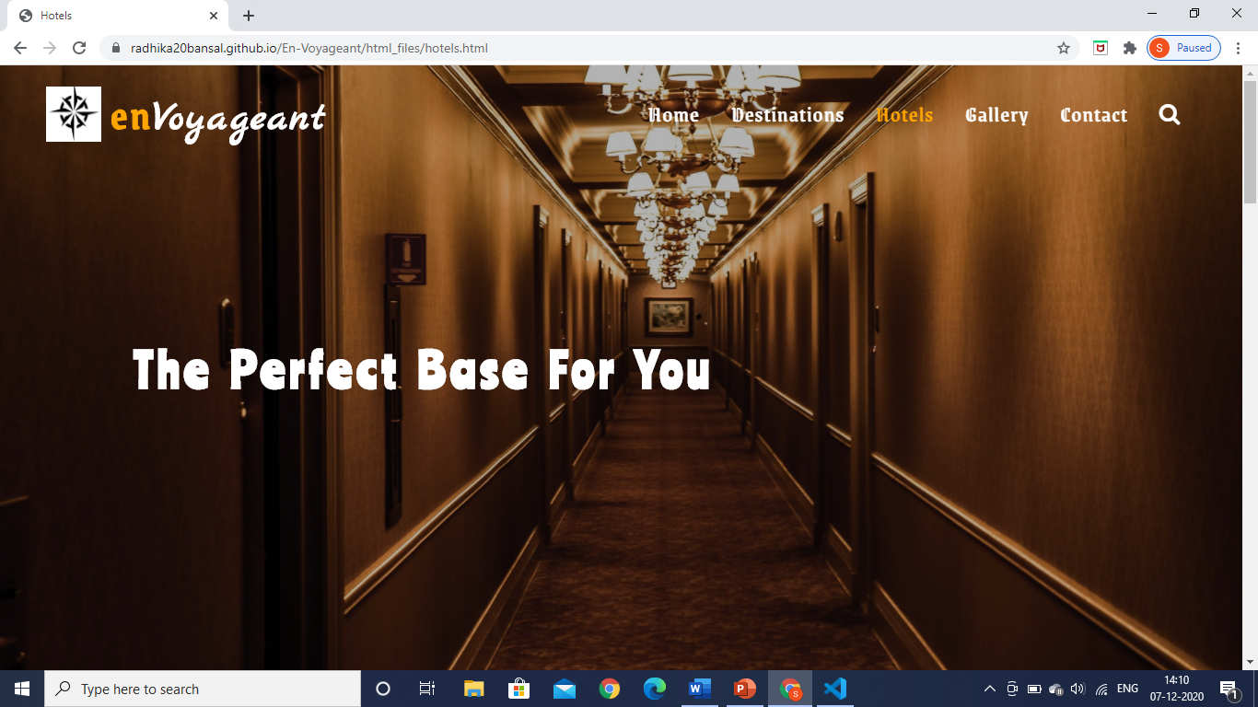

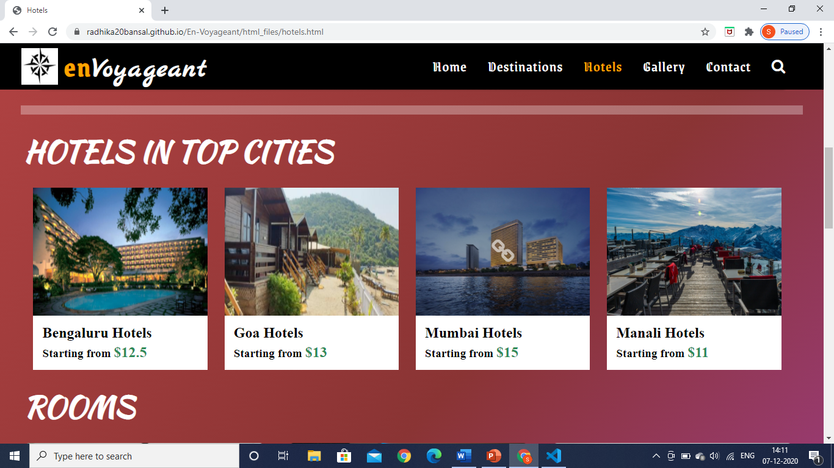This section has cards according to the hotel places like where you want to find a hotel in which city you are planning your tour, on that basis you can manage to search hotels.

This section includes some cards for rooms of your choice with various catergories.

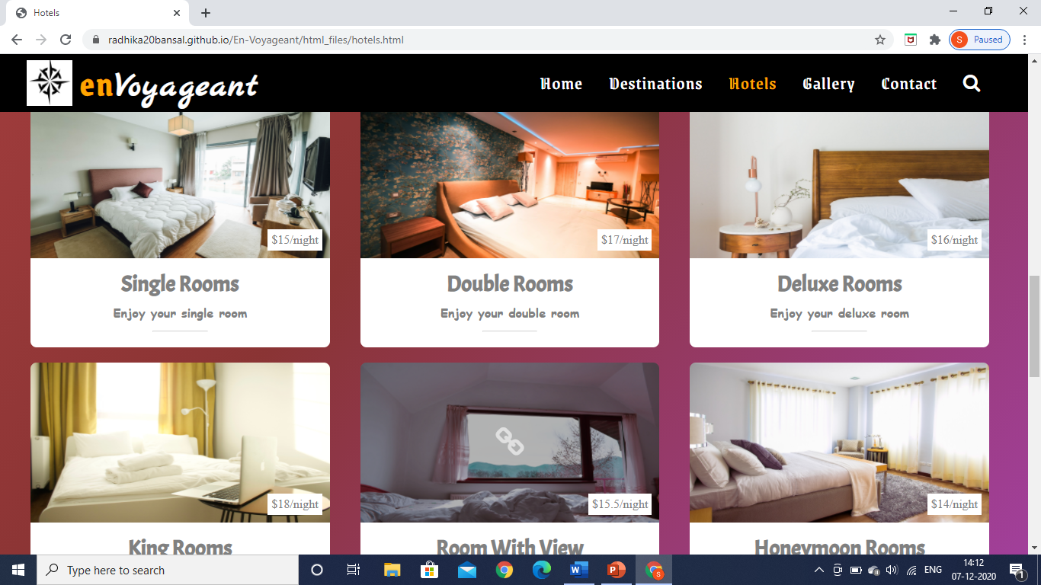

Here, You can book your hotel by adding your place and with this we reditect you at that page to book hotel of your choice and it also consist a video to look at the hotels .

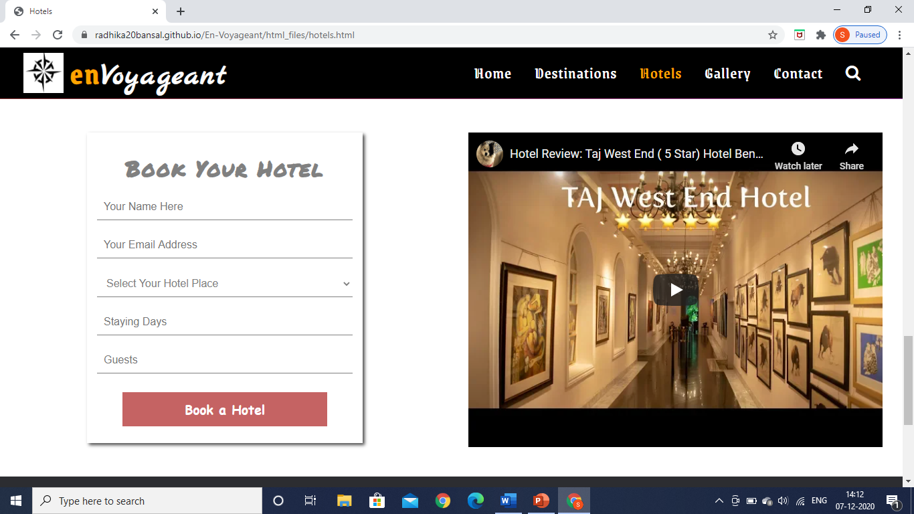

5. Gallery Page:

It is the gallery of our site. The tourists who take tour of India will find such great places to travel and will have a great experience. On clicking an image it open a lightbox gallery so that the image enlarges and you can view the whole image properly.

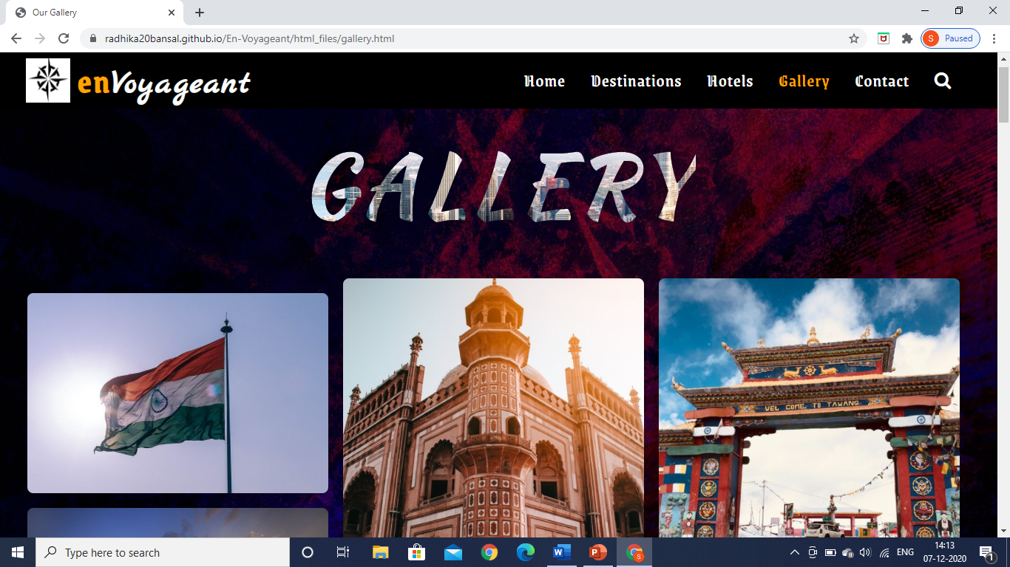

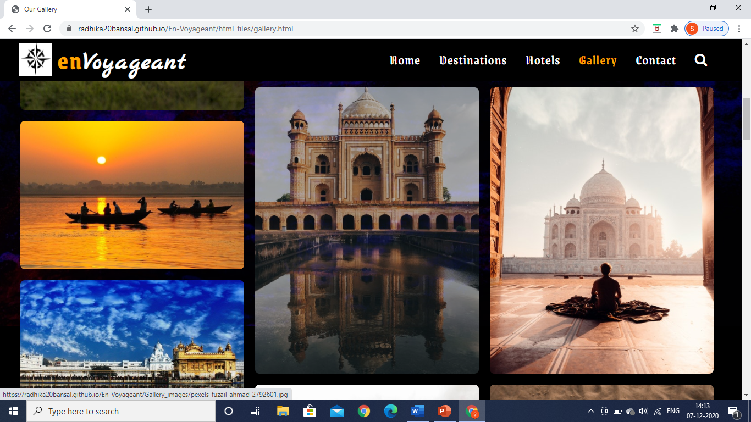

6. Contact Page:

This page contains our contact details and if you want to be contacted then you can fill in your details in the form and we will contact you with that. Behind the form and the details there is video running which is responsive to every device size.

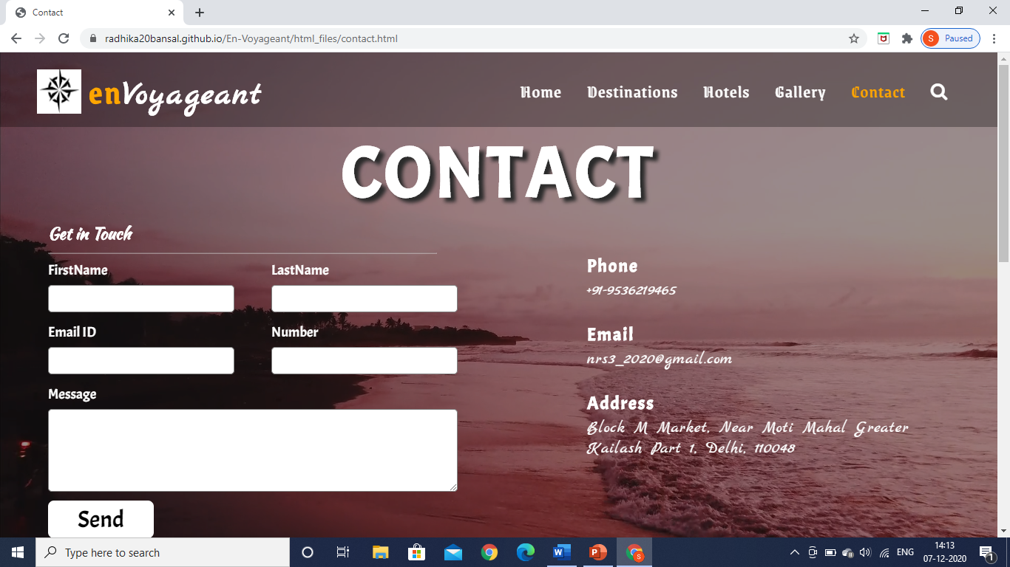

It is the map of our location where we reside.

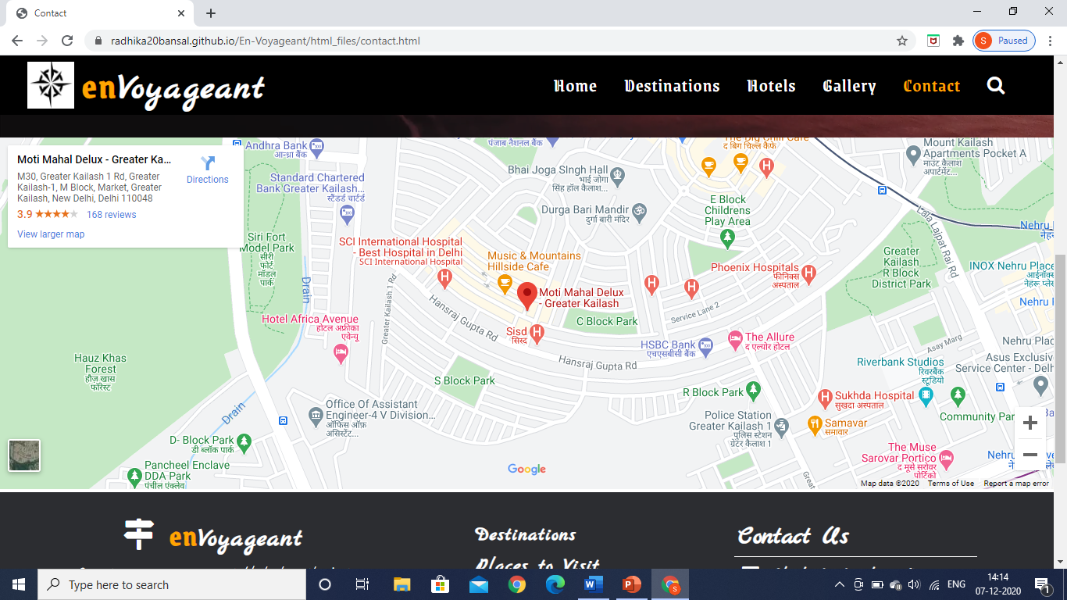

***Conclusion***

*Tourism is a major driver of economic growth globally. This website has potential commercial benefits. This website will help in promoting tourism in our country. This website includes impulse travel, collaborative booking and better packaging mechanisms which are not present in nowadays online travel portals. The expertise of travel agents should be done online. The presentation of travel destinations can be done better; 3D visualization of the destination places with high-quality photography which will lead in captivating the viewer's attention. This application can easily implemented under various situations. Hence we conclude that we make our users available with the amazing and clear visuals and with correct information.*

***References***

* *Travelling Website Templates (UI)*
* *W3School website*
* *Wordpress*

***Online Git Repository***

*Link of project github repository:*

[*https://github.com/radhika20bansal/En-Voyageant*](https://github.com/radhika20bansal/En-Voyageant)